**Rohith Kumar Agiru**

**Coursera – Website for online courses.**

**Coursera: https://www.coursera.org/**

It is an online course website, which offers a wide range of categories to learn like Development, Design, Business, IT & Software, Office Productivity, Personal Development, Marketing, Lifestyle Photography Health & Fitness etc. Some courses offer technical certification. Instructors engage their students via online discussions and provide helpful materials. We can earn an online master’s degree from this website.

**Usability Motivation Category:** Office, home, and entertainment applications

**8. Golden Rules of Interface Design:**

**Golden Rule #1: Strive for consistency**

Consistency is observed on this website. For example, when a user registers and starts a course on its website and halts then he/she will be able to resume right from where they left from its mobile application. The look and feel of the website highly resemble with its mobile application and maintains consistency so it makes easier for the users.

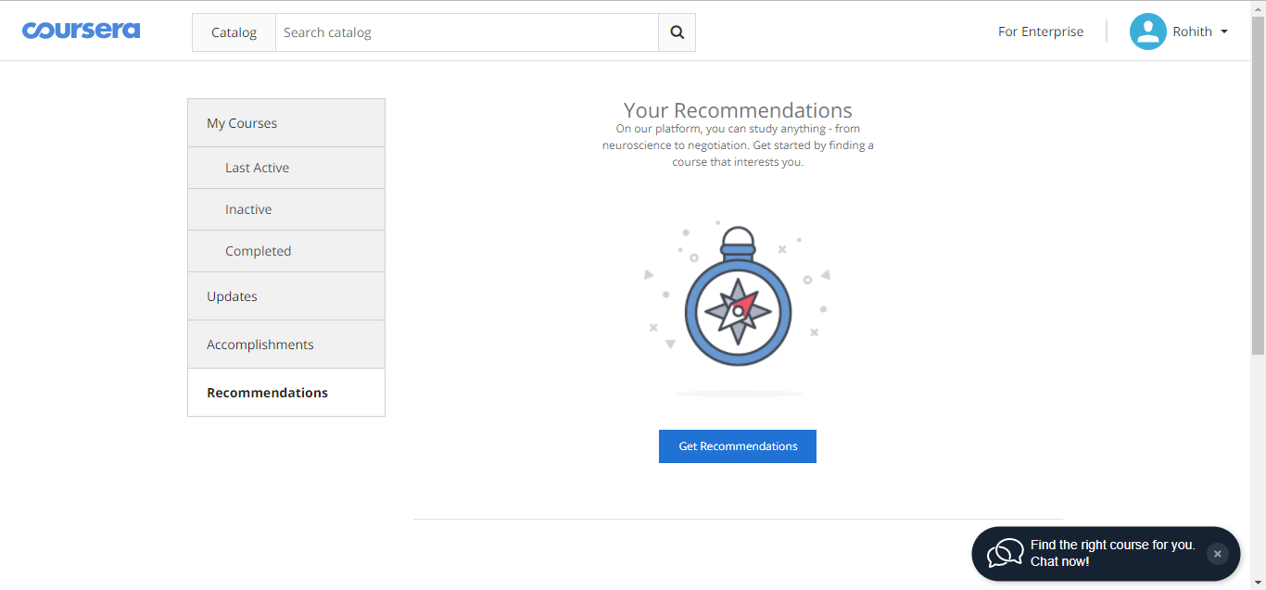

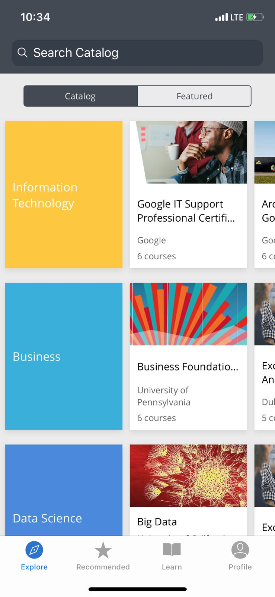 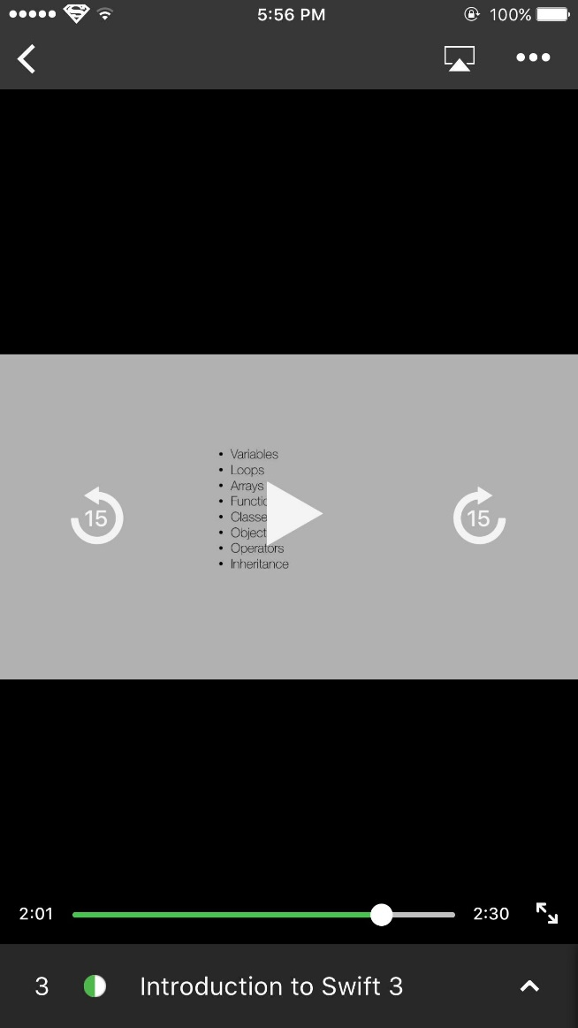

**Golden Rule #2: Cater to universal usability**

A wide range of people can use this website ranging from kids to older people who have basic knowledge of computer. I think this website does not adhere to universal usability because the users should acquire minimum basic knowledge of the course they are about to learn. For example, a user who wants to register in JAVA should have basic knowledge of any programming language like C or C++ to better understand the course.



**Golden Rule #3: Offer informative feedback**

It offers informative feedback. For example, when the user moves the cursor on the navigation bar on the homepage it highlights the selected item from the hierarchically structured list. Another good example for informative feedback is when the user points to a course, then information like duration, of course, a number of lectures can be seen, and under “My Courses”, users can see their progress.

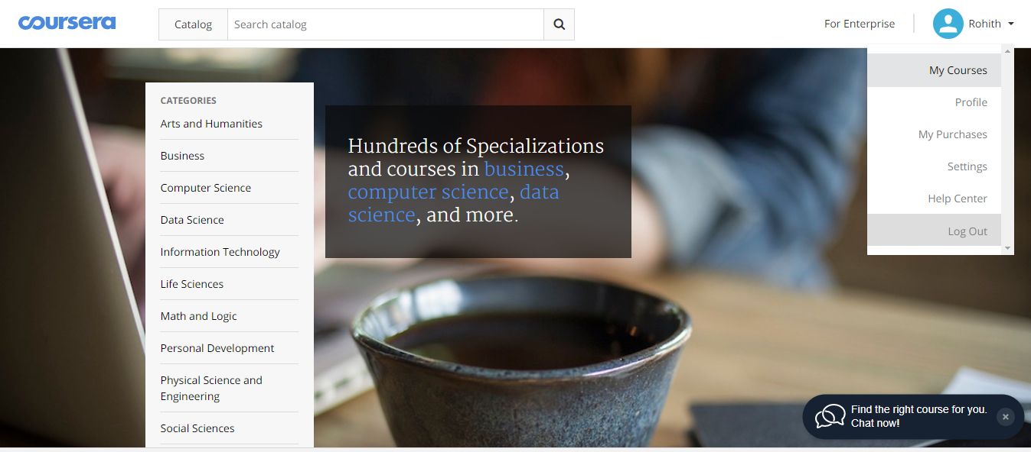

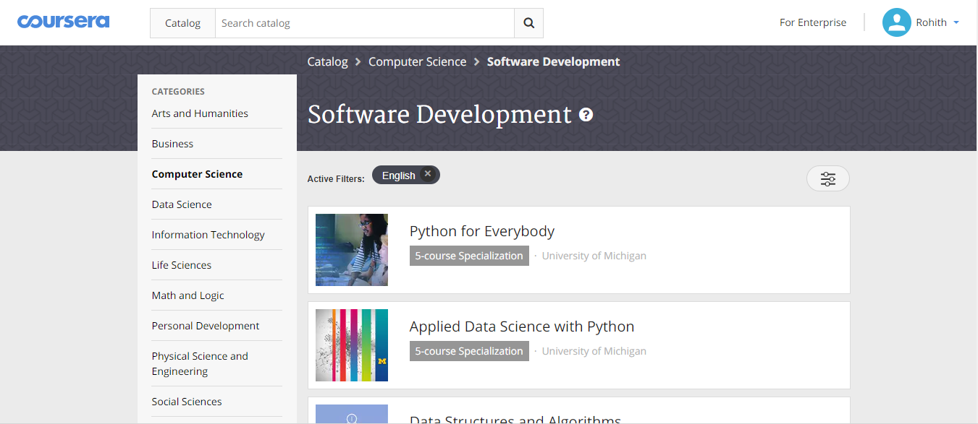

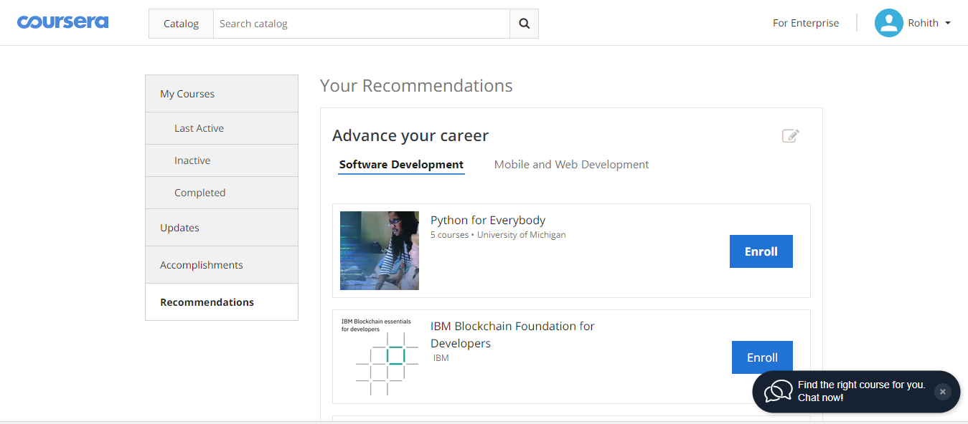

**Golden Rule #4: Design dialogs to yield closure**

It provides dialogs when you want to search for a course and while creating a course. For example, while creating a course it prompts for course title, course requirements, price etc. It also provides dialog boxes while taking the quiz to display the scores of a course and while trying to reset the course progress.

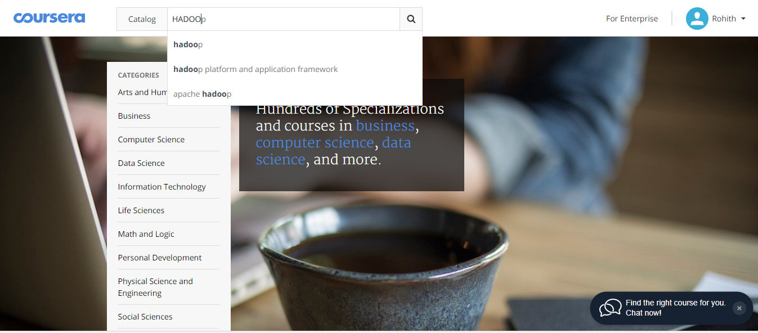

**Golden Rule #5: Prevent errors**

While user trying to reset his/her progress for a course then a message is displayed saying “All lecture and quiz progress will be reset. Do you wish to proceed?” This suggests that website is preventing errors.

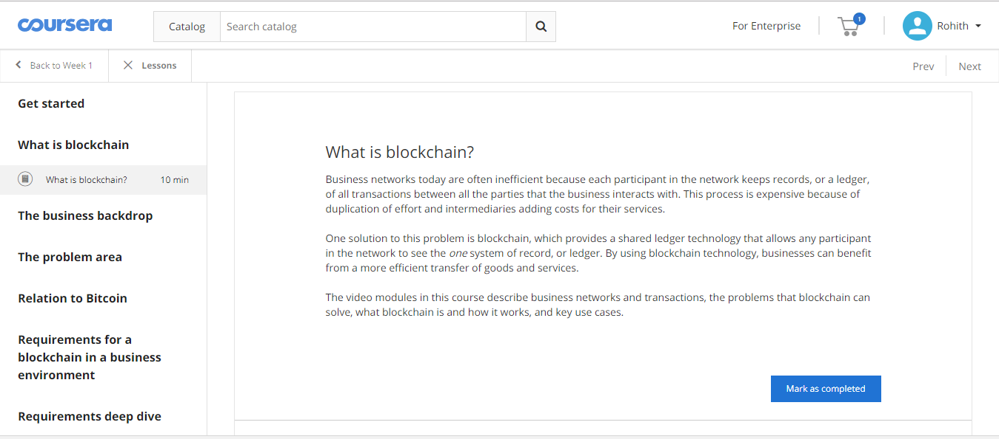

**Golden Rule #6: Permit easy reversal of actions**

It permits easy reversal of actions. For example, after completing a course user can give ratings and can also edit and resubmit his/her ratings for that course.

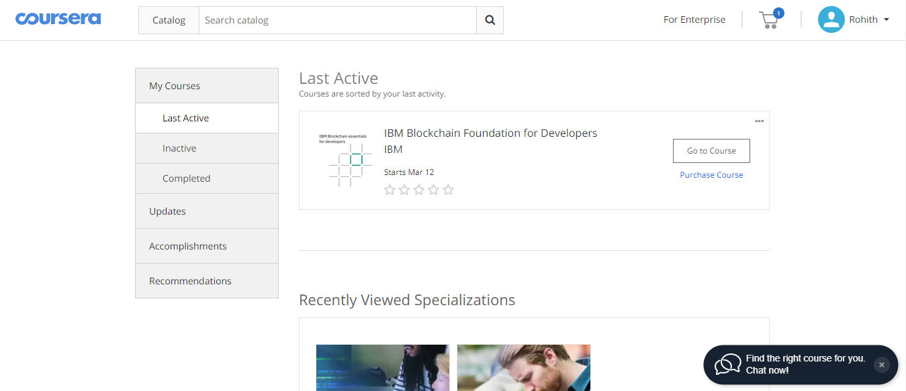

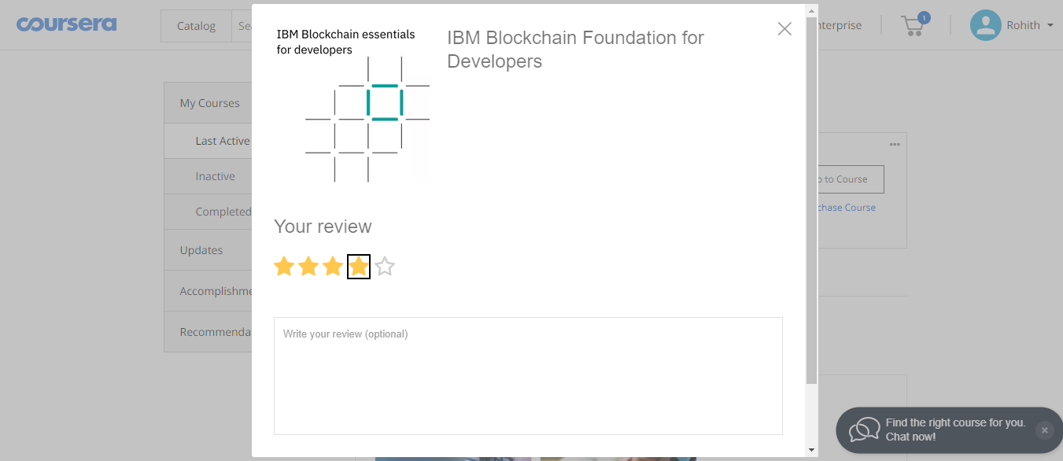

**Golden Rule #7: Keep users in control**

It supports internal users in control. For example, when the user enrolls in a paid course he/she have complete control over the course and can also gift it to a friend or others.

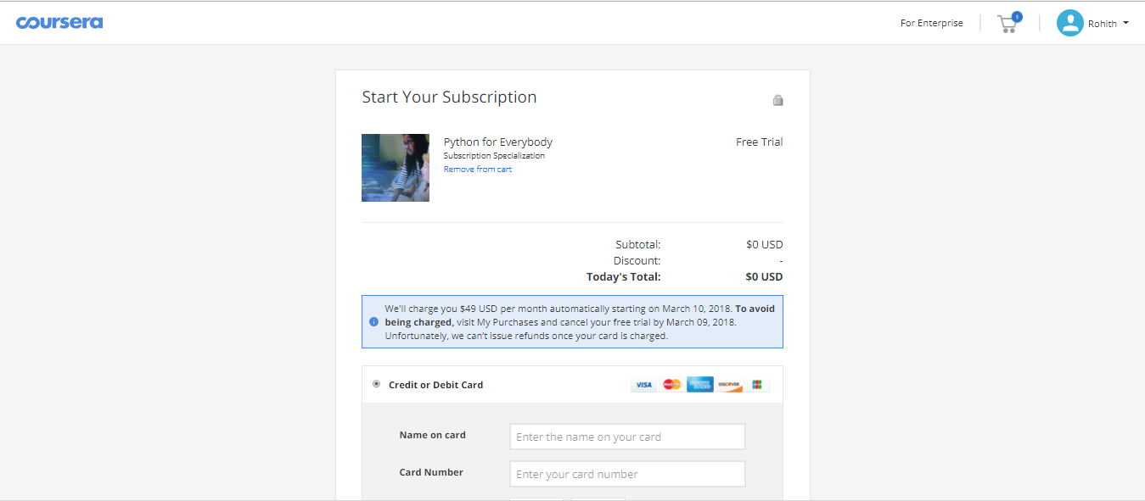

**Golden Rule #8: Reduce short-term memory load**

The user need not remember much about the website. It is mostly self-explanatory because it UI is simple to use with lots of menus, combo boxes, icons etc. It lists out the enrolled courses by sorting with the percentage of completion or recently enrolled etc.

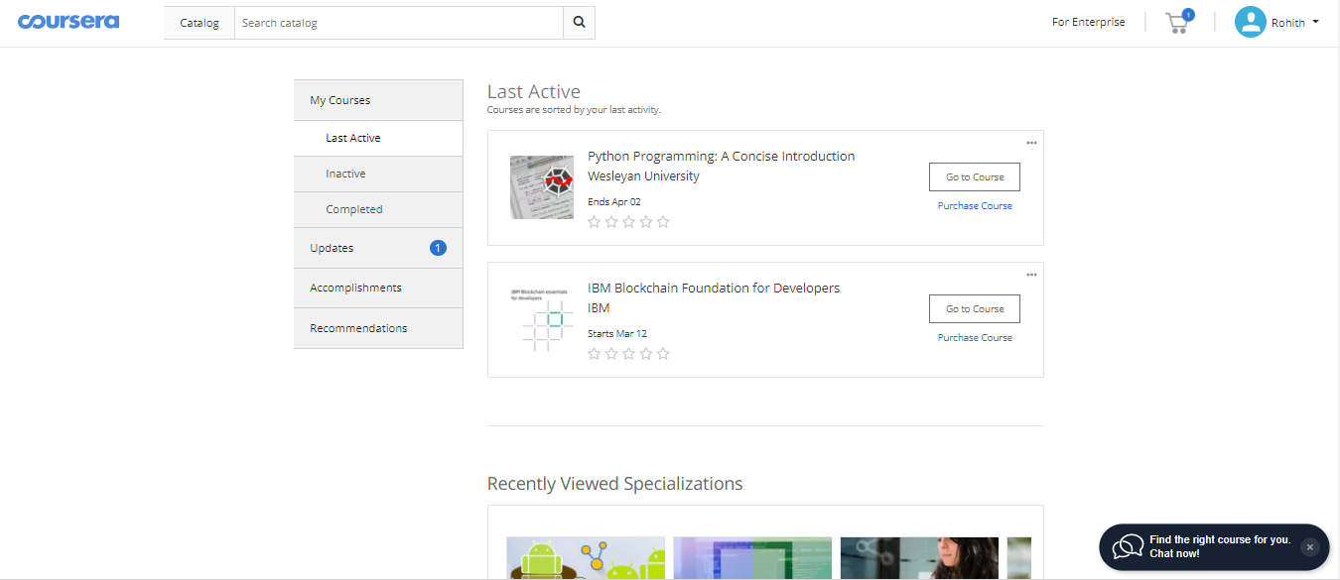

**Web Analysis:**

Coursera is consistent in many areas but lacks universal usability. It follows all the golden rules except the usability. It offers immediate and informative feedback, which is very crucial. It is beautifully designed by providing useful dialogs and prevents errors by its simple and user-friendly alert messages. Coursera permits reversal of actions in few areas and gives internal locus of control for the users. Finally, it is very easy to use and interact such that user need not worry to remember much about the website.

**Sai Praneetha Jaladanki**

**Etihad Airways - Website for Airline flight tickets**

**Website: http://www.etihad.com/en-us/**

**Usability Motivation Category:** **Industrial and Commercial uses**

**8. Golden Rules of Interface Design:**

The design of this website is for the airline company Etihad Airways, based in Abu Dhabi. This site offers services like booking airline tickets, hotels, cars and the user can find the status of any booking thus made.

**Golden Rule#1: Strive for Consistency:**

This website is consistent as we can observe that the font of the website maintained is same. Al the tabs in the site have the same font thus making it consistent. The font size is readable and acceptable. The site has brown and yellow colors throughout the homepage. Different actions are be performed without any disturbance, as the site is well portioned.

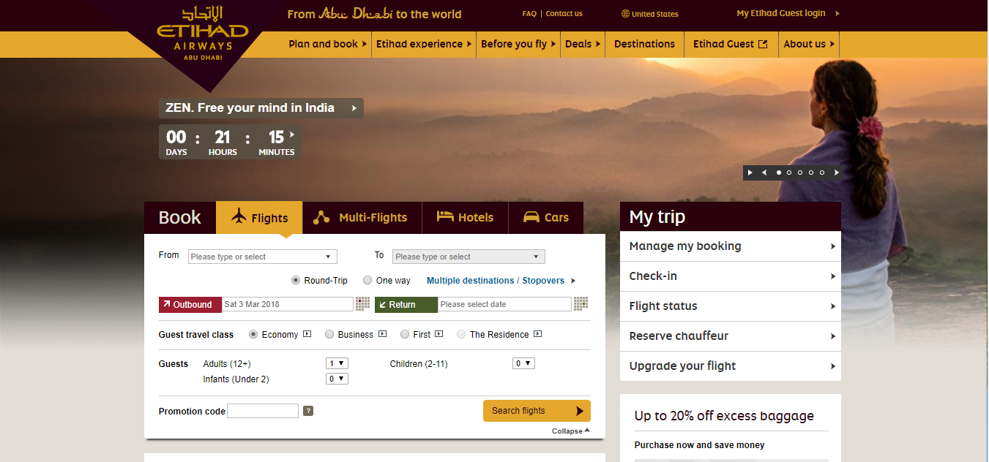

**Golden Rule#2: Cater to universal usability:**

Etihad Airways website is accessible from any place. It offers to change country and region along with the language for the site. The site also has an app that is downloadable on a smartphone and is unable to do the same functions as in the site. It is responsive and fits on the screen of all devices.

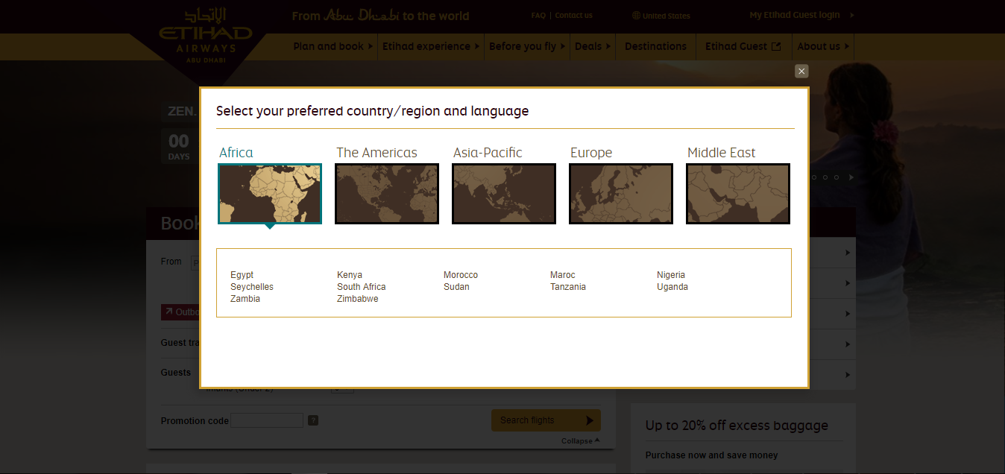

**Golden Rule#3: Offer informative feedback:**

When the user selects round trip and chooses an only one-way date, and forgets to enter the return the site provides an action to enter the return date. This message allows the user to correct themselves and enter the return date. This is an informative feedback given on the website.

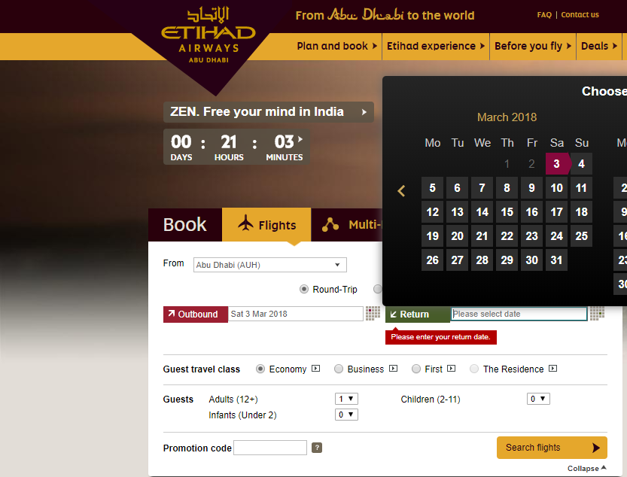

**Golden Rule#4: Design dialogs to yield closure:**

The website provides step by step and relevant feedback after each action is performed. After the user provides the required information to search flights there is a tab bar displayed which describes the process to the user in sequential order. After each action of the tab is perfumed there is relevant feedback provided to the user, e.g. when the results for available flights are shown, the options that the user entered for the results are also shown on top of the results and after the payment is done a confirmation is provided to the user. This relevant feedback gives user relief and operates the website easily.

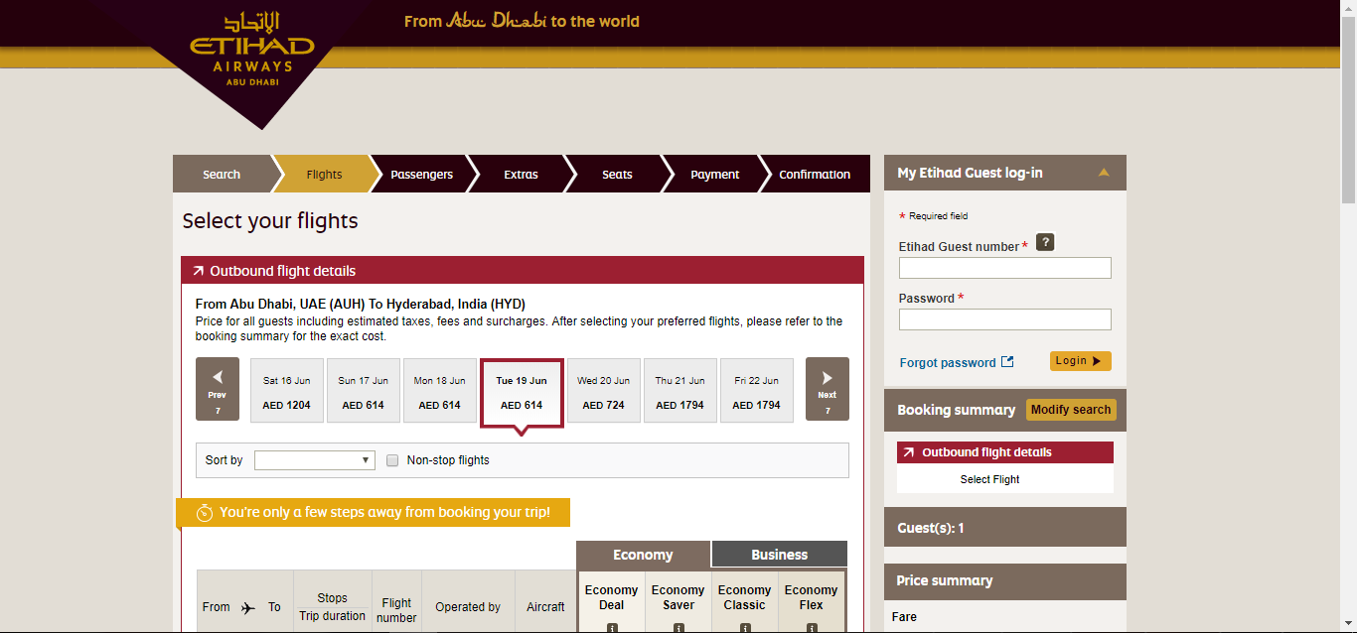

**Golden Rule#5: Prevents Errors**

The website prevents error displaying the day of booking to further out so that the user cannot book the car on the very and immediate date.

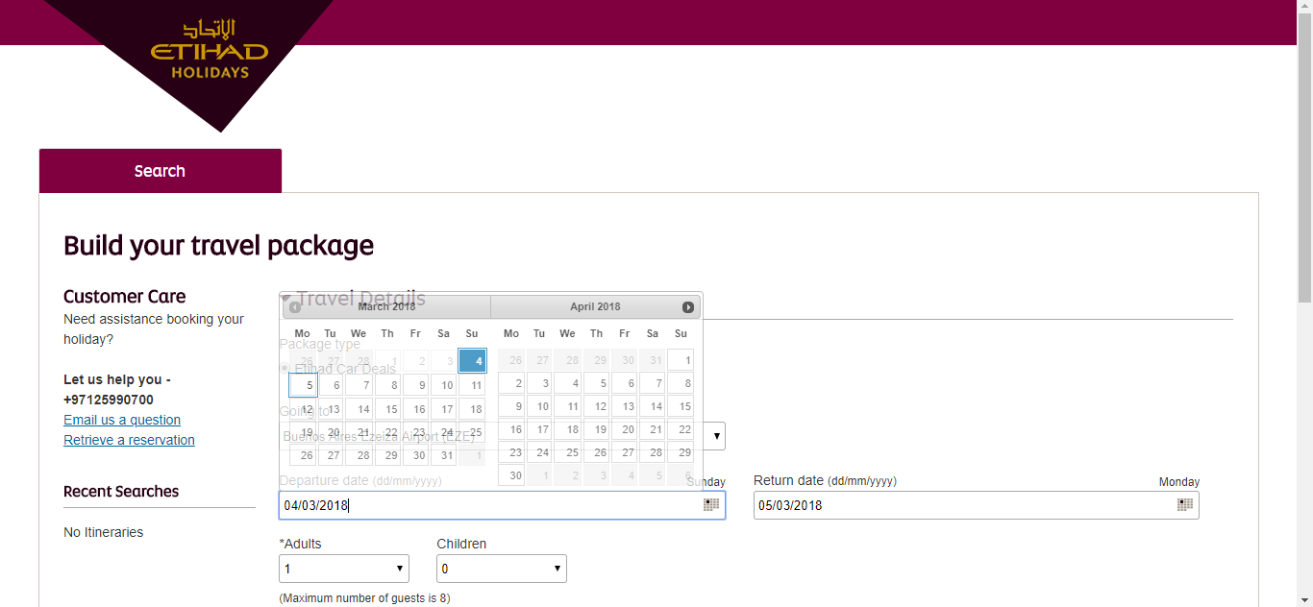

**Golden Rule#6: Permit easy reversal of actions:**

The website provides an easy reversal of actions, as the user can easily switch back to any of the pages in the website by just clicking the links in the header bar. If the user wants to navigate the previous page he/she can just go back to hitting the back button. Suppose the user searched for hotels and he/she wants to cancel a ticket in sudden then the user can directly come back to the cancelation screen by just clicking the manage link provided on the top of the website.

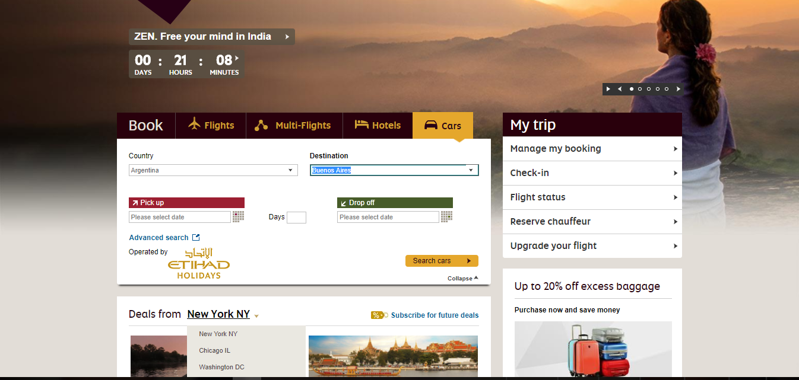

**Golden Rule #7: Keep users in control**

If the user is a frequent one, then it is very easy for them to perform different action too fast. The speed to perform the task is acceptable. Any new information is flashed on the home page where the users can easily view it click it. All these actions can be performed in an Executive club.

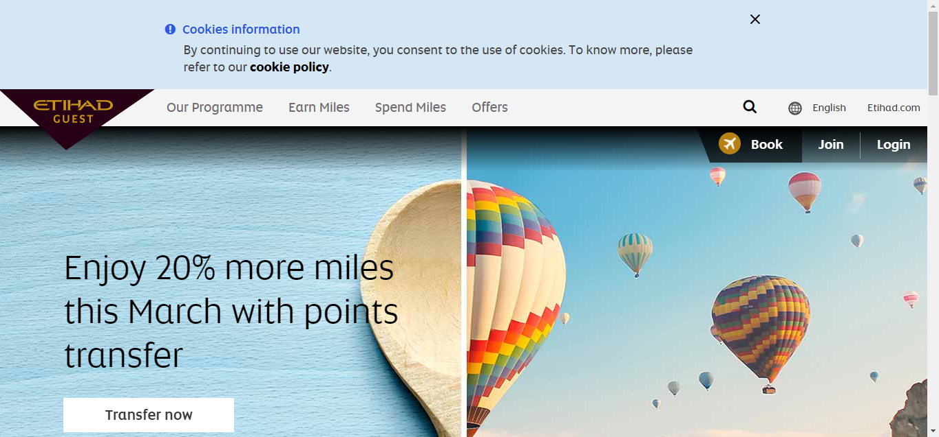

**Golden Rule#8: Reduce short-term memory load:**

This website makes it very clear to the user by making everything visible in the world than making the user think what to do. For every task, we have links to click by which we are directed forward till the task is achieved. For returning users who have booked the ticket can utilize all the additional services like manage the booking, check flight status, baggage allowance, etc.

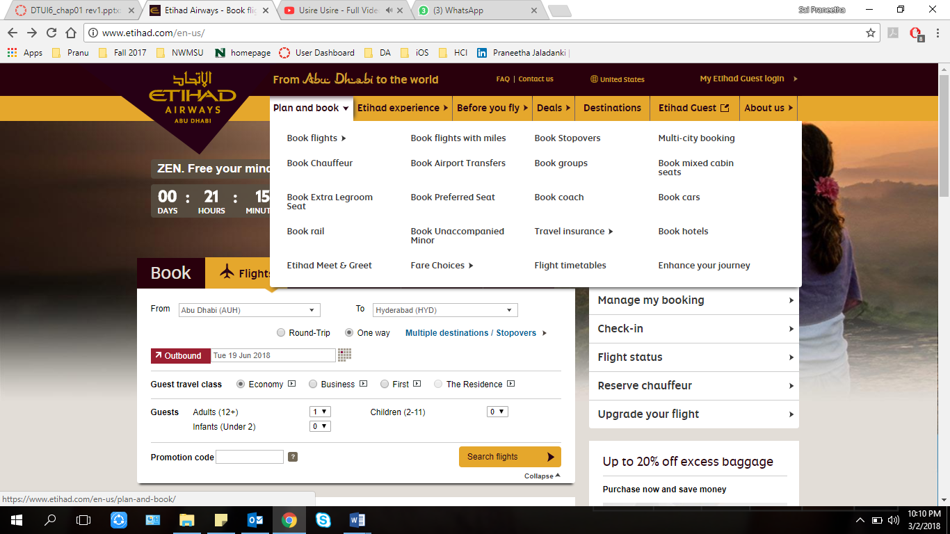

**Web analysis:**

Etihad Airways is applicable to all the golden rules. It is consistent, achieves usability also and provides informative feedback. By providing accurate prevention of error messages, it helps in validating the fields and hence doesn’t allow the user to book any wrong reservations. It also accommodates easy reversal of actions with short memory load on users. Since it satisfies all the factors, it is considered as a very good website.

**Saiteja Jonnalagadda**

**AliExpress – Website for online shopping**

**Website:** [**https://www.aliexpress.com**](https://www.aliexpress.com)

This is an online shopping website which allows purchasing different types of products such as men clothing, women clothing, gadgets, toys, jewelry etc.. online and also to sell products online. Products ordered in this site will be delivered to our address within a particular amount of time. We can compare the price of the product in different brands. We can add some products to wishlist so that we can view and purchase that later by signing into his account.

**Golden Rule#1: Strive for Consistency:**

The products on the website can be viewed without signing into the website. To order any product it is mandatory to sign in. If we are first time user we have to sign up to the website. Sign in is an essential factor to order products, we cannot give our address and we cannot add payment without signing in. If we want to track our product shipment we need to login to our account. We can also check our previous order history by signing into our user account.

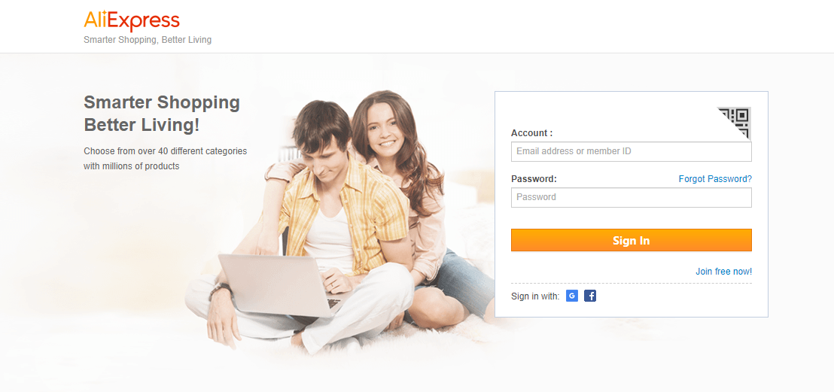

**Golden Rule#2: Cater to Universal Usability:**

Catering to universal usability is one of the main features of Aliexpress. The user can search for products of his interest. The Aliexpress also generates and shuffles products based on the location. For suppose you are in the United States, then it provides all popular products and trends present in that country. It also gives suggestions based on our previous search history. Even if you are anywhere in the world and change the country option to a particular country it offers the products related to the specified country you provided. This universal usability provides the products usable for every citizen.

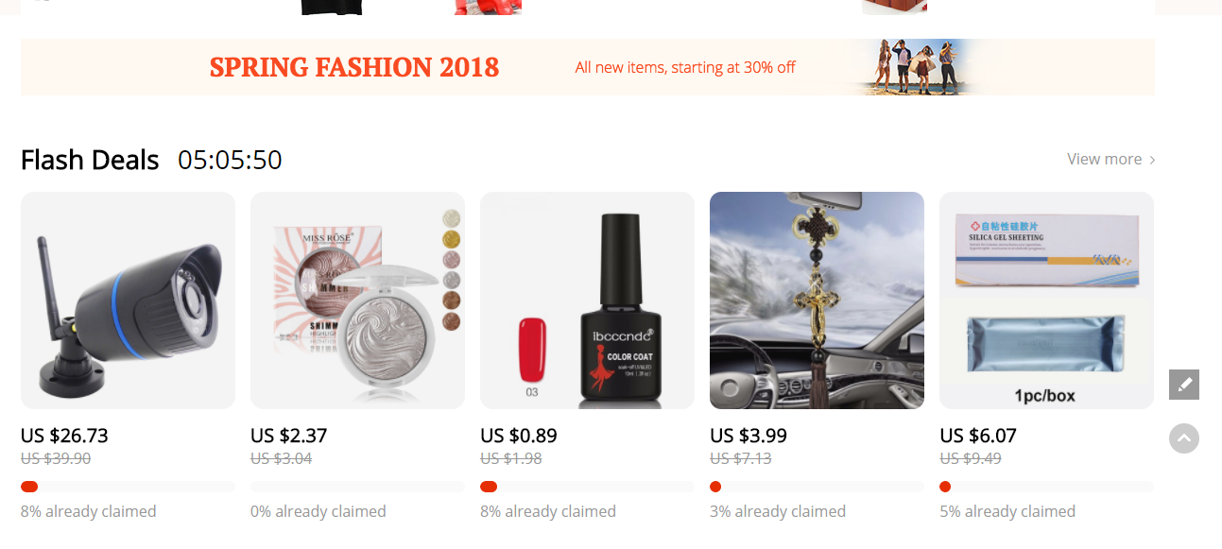

**Golden Rule#3: Offer Informative Feedback:**

Aliexpress offers a very good informative feedback to the user. When we want to buy any product like shoe we should select the color of shoe and size of shoe. The feedback of the selected details will be marked in orange color so the user can confirm his selection. If we buy any electronic item it asks to select the type of the input power such as USB or three pins male socket.

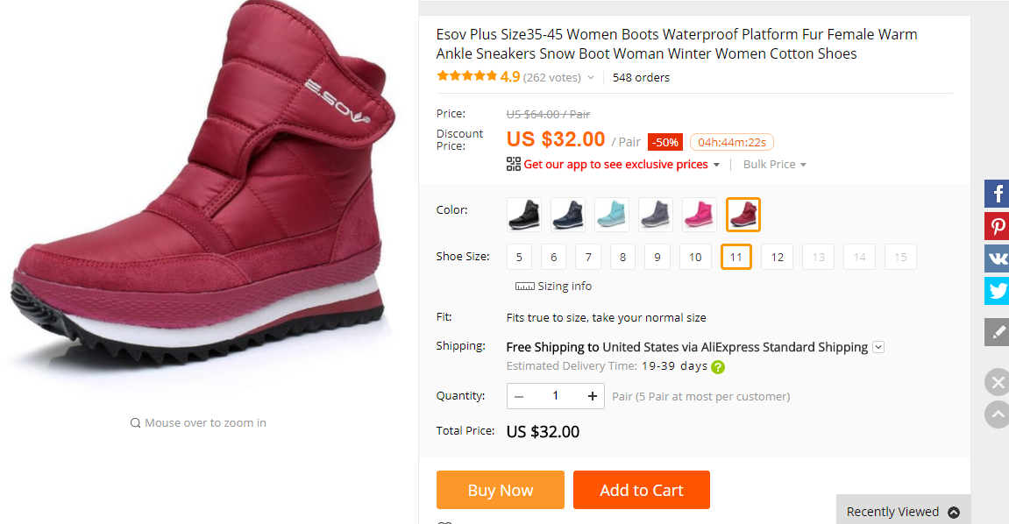

**Golden Rule#4: Design dialogs to yield closure:**

This website also provides design dialogs, which helps the user to complete an action sequence. For example, if the user selects the item to add to wish list it gives a pop up showing that the item has been added to wish list. Also, if the user adds the item to cart a pop up comes showing that the item has been added to cart.

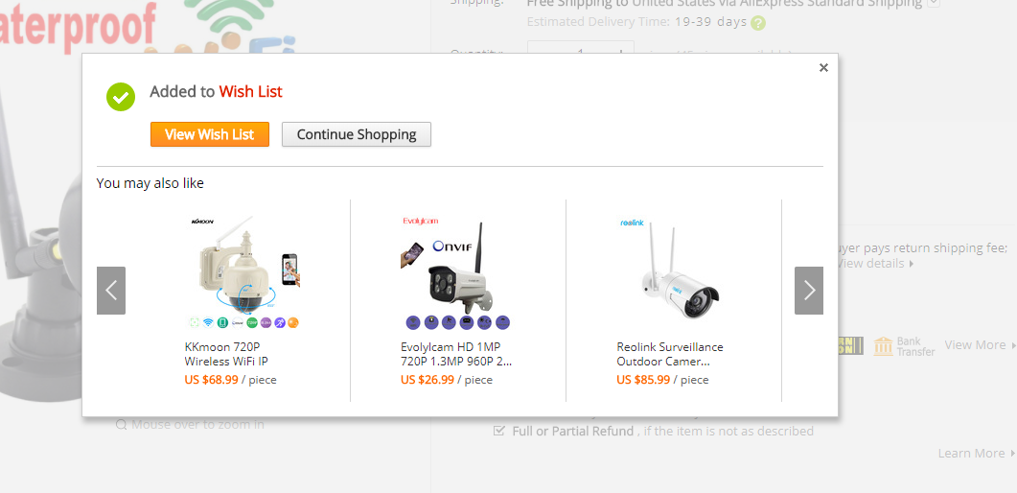

**Golden Rule#5: Prevent Errors:**

Aliexpress introduced a notification system for a policy restricting the types of content that may be incorporated. While giving an address for delivery if we fill our area zip code wrong it gives error message showing that the zip code is wrong. And same with the phone number field. Also while giving our payment details if we enter wrong credit card number it gives an error message.

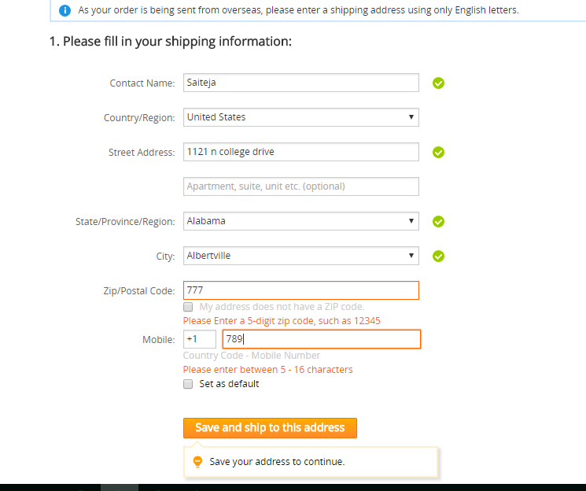

**Golden Rule#6: Permit easy reversal of actions:**

Easy reversal of action is essentially possible on the Aliexpress website. If we add an item to the cart by mistake we can remove the item from the cart by selecting remove button appropriate to that item. Same with the wish list we can remove the item which is added by mistake.

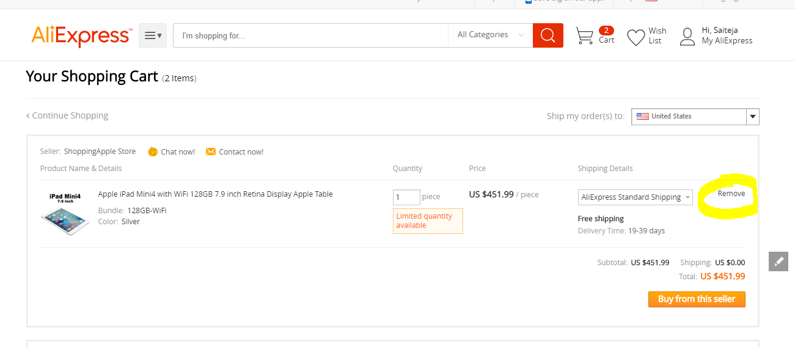

**Golden Rule#7: Keep users in control:**

Aliexpress does support users in control. Users are responsible for their actions for what they type in. They will be getting results for the actions they type in. Example: If you type in “iPhone x case” then you will be getting results only related to iPhone x case.

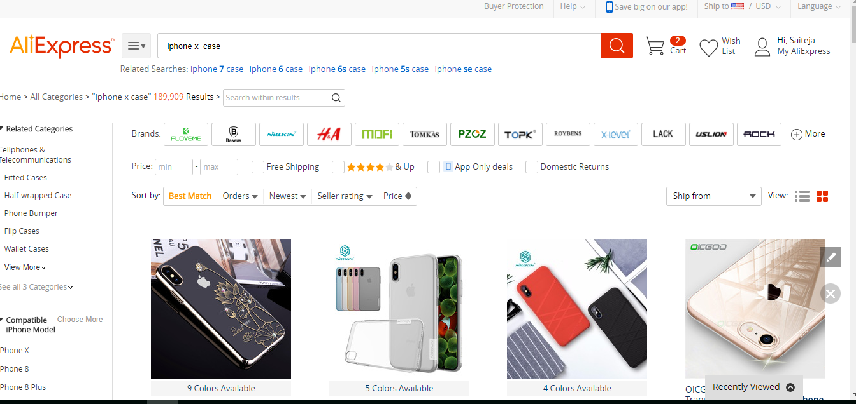

**Golden Rule#8: Reduce short-term memory load:**

Most of the Aliexpress buttons, search bar, and menu options are available upon opening the website, which actually reduces humans from remembering things for a short amount of time. Even when searching for a specific video just remembering the partial name helps you get the video rather the entire name. In such a manner it supports reducing the short-term memory load. Example: If I wanted to search product named “Ipad air 2 cases” after a long time and if I forget to remember the second word and only remember the first word, then YouTube identifies the show while we type the first word partially and pops up in the search bar.

